[Label a Bat!](http://ngexplorer.cengage.com/ngyoungexplorer/0710/index.html)

**Directions:**

1. “Drag and Drop” each label to the part of the body of the bat.

2. Then, right click on the title of this work sheet and open the link to listen and read an e-book on bats.

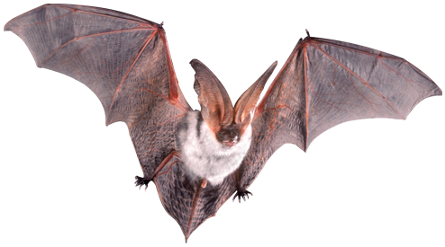

**finger**

**body**

**foot**

**ears**

**wing**