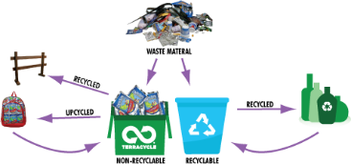Name: Click here to enter your name.

**Copy and Paste Recycling Rules**

Copy and paste each picture into the correct column.

|  |  |  |  |
| --- | --- | --- | --- |
| **Recycle** | | **Do *NOT* Recycle** | |
| **glass jars** |  | **food** |  |
| **paper** |  | **plants** |  |
| **plastic bottles** |  | **cloth** |  |
| **metal cans** |  | **books** |  |
| **cardboard** |  | **other trash** |  |

|  |  |  |  |  |
| --- | --- | --- | --- | --- |
| http://s.hswstatic.com/gif/recycled-glass-jar-crafts-1.jpg | http://www.madlantern.com/art/clips/garden/potted-plant.gif | http://www.gonzaga.edu/Campus-Resources/sustainability/Images/cans.jpg | http://www.wlssd.com/images/content/recycle_cardboard.jpg | Image result for newspaper |
| Image result for hamburger and fries clipart | http://www.blogcdn.com/www.slashfood.com/media/2008/05/promos-potato-chips-425rb052108.jpg | http://cliparts.co/cliparts/BTa/EaB/BTaEaBn9c.png | Image result for plastic bottles | http://www.readcwbooks.com/books.jpg |